Corrective Action Plan
ABC Foster Care Services

Foster Home: Banks, Phillip or Vivian
GA SCORE Foster Home ID: 55555
Date: January 1, 2024
- Name and DOB of Foster Children in the home

Child’s Name DOB
Will Smith 5/5/2015
Hilary Banks 7/15/2010
Carlton Banks 6/4/2012
Ashley Banks 4/23/2016

- Reason and Purpose for Corrective Action Plan:
Mr. and Mrs. Banks failed to complete their required training hours by December 31, 2023. Both caregivers indicated that they didn’t know they needed training and wasn’t given much information about how they could obtain training. The purpose of this corrective action plan (CAP) is to ensure that Mr. and Mrs. Banks understand the continued training requirement and complete all outstanding training requirements.

- Plan for completion of training:
- Weekly reminders (via texts, emails, and phone calls) will be sent to the Banks family regarding training hours needed each Monday by the agency Resource Development/Licensing Specialist and/or Designee.
- Mr. and Mrs. Banks will complete a minimum of three (3) hours of training by each Friday.
- Every Friday by 5:00PM, Mr. and Mrs. Banks will send training certificates and/or proof of attendance to the agency Resource Development/Licensing Specialist and/or Designee.
- ABC Foster Care Services will consult with Georgia Center for Resources and Support and the Division of Family and Children Services about the Banks family and ask for additional assistance with making sure they meet their training requirements.

- Dates of Completion:
- Mr. and Mrs. Banks will each have all fifteen (15) of their 2023 Continued Development training completed by January 31, 2024.
- Mr. and Mrs. Banks will have a minimum of twelve (12) hours completed by January 22, 2024.
- Mr. and Mrs. Banks will submit remaining training certificates to ABC Foster Care Services by January 29, 2024.
- ABC Foster Care Services will contact Mr. and Mrs. Banks each Monday (January 1, 8, 15 and 29) to discuss progress with completing their training and assist with resolving any barriers until all their training hours are complete.
- Mr. and Mrs. Banks will attend the local foster parent meeting held on January 23, 2024, for an additional two (2) hours of training.
- Mr. and Mrs. Banks will have their updated CPR and First Aid Training completed by January 19, 2024.

- CAP Effective:
Mr. and Mrs. Banks Corrective Action Plan (CAP) will be effective starting Jan. 1, 2024, to January 31, 2024. If Mr. and Mrs. Banks fail to have training completed by January 31, 2024, ABC Foster Care Services will have a meeting with both caregivers to discuss next steps and possible home closure due to continued noncompliance.

Signatures and Dates:

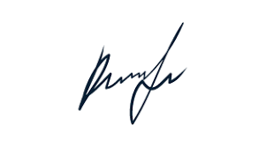
Primary Caregiver 1/26/2024
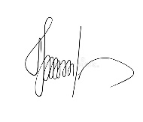
Secondary Caregiver 1/26/2024
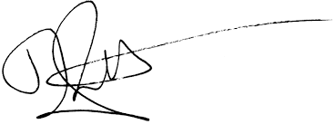

Director/Designee 1/26/2024

